BTS-NDRC – ANGLAIS (LV1)
SUJET 0:
Partie 2: Mise en situation
Costco store
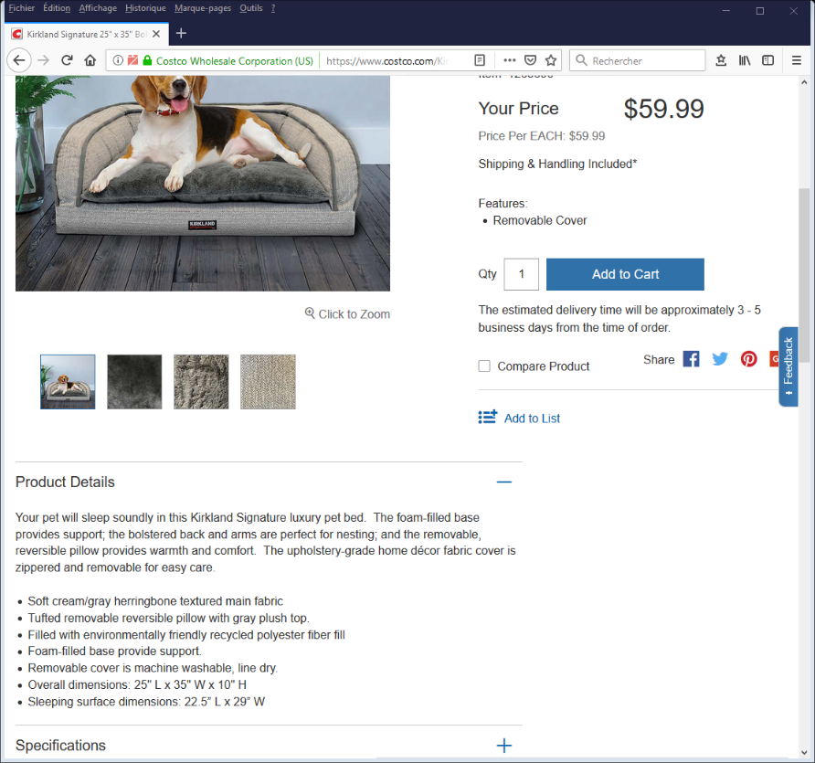

https://www.costco.com/

Costco store in Cornwood has bought a small number of Kirkland Signature Bolsterbeds to test their attractiveness among their costumers.
You are asked to write a newsletter.
- Identify your customer base.
- List the assets of the product.
- How would you make the newsletter attractive and efficient?

