BTS NDRC – ANGLAIS (LV1)
SUJET 0

Partir 2 : Mise en situation

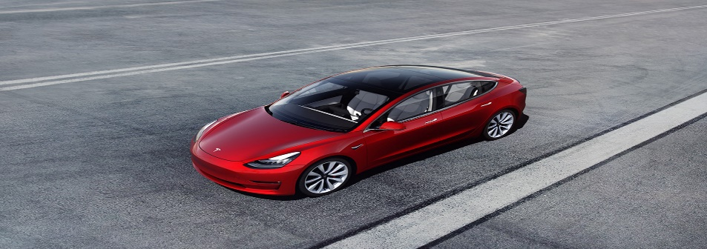
Model 3

Model 3 is a small, simple and affordable electric car. Designed and built as the world’s first mass-market electric vehicle, it is a critical step in Tesla’s mission to accelerate the world’s transition to sustainable energy. Like every Tesla vehicle, Model 3 combines range, performance, safety and technology. Model 3 is currently in production. Deliveries begin Mid 2019

STANDARD EQUIPMENT Base Price - $35,000

Standard Battery
- Range: 220 miles (EPA estimated)
- Supercharging rate: 130 miles of range per 30 minutes
- Home charging rate: 30 miles of range per hour (240V outlet, 32A)
Performance
- 0-60 mph: 5.6 seconds
- Top speed: 130 mph
Interior
- 15” touchscreen display
- Dual zone climate control system
- Front center console with open storage and
two USB ports

Convenience
- Maps and navigation with real-time traffic-based routing
- Wi-Fi and cellular internet capability
Safety
- Eight cameras, forward radar and twelve ultrasonic sensors enabling active safety technologies including collision avoidance and automatic emergency braking
- Child safety locks
- Anti-theft alarm system
Warranty
- Vehicle: 4 year/ 50,000 miles warranty
- Battery warranty: 8 year, 100,000 mile (120,000 mile with Long Range Battery)

OPTIONS
Model 3 can be customized with various options and packages, and is available in a number of different configurations, including Dual-Motor All-Wheel Drive for superior performance and traction in any weather and Model 3 Performance for best-in-class acceleration. Please visit our Design Studio to see all currently available options and specifications for Model 3. https://www.tesla.com/fr_FR/presskit#model3

SITUATION:
You work as a sales advisor at Tesla and have a meeting with a potential customer who is hesitating to buy your Model 3. Prepare your arguments to reassure and convince him/her and satisfy his/her needs. He/she is worried about:
  - Its autonomy and the battery charging rate
  - The delivery time /availability
  - The after sales service / maintenance
  - The price of options

